**Project Report**

**Topic: Smart Dustbin**

**Prepared By:**

**Dhruvil Sheth(16BIT011)**

**Margi Panjvani(16BIT027)**

***Project Description***: For effective waste management system, proper and timely collection of garbage is required. To reduce the time and energy of the garbage collectors it will notify whether the dustbin is full or not. Automatic lid opener to prevent spreading of germs and diseases. Most important application of Smart Dustbin is in the areas where frequent collection of garbage is not required to save time and energy of resources

***Overview of tasks:*** Started the project with gathering information about various types of sensors and its general applications. Next we selected specific sensors which can be used in our projects along with the sensor models. Further the schema of the project was designed using online schema generator named DB Designer. Prepared relational and SQL queries. Installed MySQL Workbench and inserted tables in it. Prepared dummy data in Excel and inserted it in SQL after converting it from CSV to SQL. Tried running queries using that data. Next we generated the updated data in Excel. Converted to SQL and inserted in MySQL Workbench. Next fired queries on different platforms like OracleLive and JDoodle. Added minimal covers, FDs and normalization. Started with website and app.

**Advantages of Database Management System over File System**

**Data redundancy and inconsistency**: Repetition of data refers to redundancy in general i.e. each data may have multiple copies. The file system cannot have control over redundancy as each user defines and maintains the needed files for a specific application to run. It may be possible that multiple users may have the same data file for different applications. Hence changes made by one user will not be reflected in the data of the other users. This eventually leads to inconsistency of data. Whereas DBMS controls redundancy by maintaining a single repository of data that is defined once and is accessed by many users. As there is no or less redundancy, data remains consistent.

In my project Smart Dustbin, if the user approaches the dustbin will automatically open. If it is full, it won’t open even if the user approaches and a query is put in database to get the dustbin emptied. So in file system multiple users(staff) can put the query multiple times but in DBMS it won’t be possible. Hence the problem of redundancy can be overcome and data will further be consistent.

**Difficulty in accessing the data:** In file system, data has to be accessed by iterating through lines and it’s a cumbersome task. Whereas in DBMS specific data can be accessed by firing a query. This also saves time. DBMS is a centralized system, it has inbuilt searching operations whereas in file system different program has to be written for every search operation. In this project, different queries are to be operated so by using DBMS different programs will not have to be written instead only small queries are to be written.

**Data isolation**: When multiple users share a database, it is likely that some users will not be authorized to access all information in the database. For example, in this project the contact numbers and addresses of staff is often considered confidential, and hence only authorized persons are allowed to access such data. In addition, some users may be permitted only to retrieve data, whereas others are allowed both to retrieve and to update. Hence, the type of access operation retrieval or update must also be controlled. Typically, users or user groups are given usernames protected by passwords, which they can use to gain access to the database.

**Integrity problems**: There may be cases when some constraints need to be applied on the data before inserting it in database. The file system does not provide any procedure to check these constraints automatically. Whereas DBMS maintains data integrity by enforcing user defined constraints on data by itself. In this project, the limit of the dustbin is to be enforced after which the waste should not be put in it, contact number of staff should be 10 digits, approximate distance etc. Implementing this in file system is difficult whereas in DBMS constraints can be easily put.

**Atomicity problems:** This property states that a transaction must be treated as an atomic unit, that is, either all of its operations are executed or none. There must be no state in a database where a transaction is left partially completed. States should be defined either before the execution of the transaction or after the execution/abortion/failure of the transaction. In this project, all the operations can be executed by the staff or the head. In file system, there is no surety whether a specific entry is fully completed. In DBMS, you can easily notice.

**Concurrent-access anomalies**: DBMS systems provide mechanisms to provide concurrent access of data to multiple users. In this project, if the data is to be accessed from multiple offices it is possible by using DBMS whereas it is not possible using file system because like database no such mechanisms in file system exist.

**Security problems**: Not every user should be able to access all the data. For example, in this project, the users cannot access the data of the staff. They do not need access to their personal details. Since, in the file systems, application programs are added to systems in ad-hoc manner, it is difficult to enforce security constraints.With central control over the database, the DBA (Database Administrator) can define the access paths for accessing the data stored in the database and he can define authorization checks whenever access to sensitive data is attempted.

**RELATIONAL ALGEBRA QUERIES**

1. Selection

(I) Print the records where weight of garbage is greater than 50 kgs.

σ*weight >50*(waste)

(II)Print the records where the waste obtained was biodegradable.

σ*type=”Biodegradable”*(waste)

2. Projection

(I)Print different areas of deployment throughout the generation of waste.

∏area_of_deployment (waste)

(II) Print positions of staffs of the employees.

∏position(staff)

3. Natural join

(I)Print the areas where employee Jay is supposed to collect garbage.

∏area(σsname = “Jay”(staff |Χ| disposal_centre_info))

(II)Print the height of wastage in dustbin from area foghoy.

∏height(σarea = “foghoy”(deployed_area_info|Χ| waste))

4. Union

(I) Projects the names of the areas who have either have the dustbin same as disposal centre.

∏ area_of_deployment (disposal_centre_info) ∪∏area (deployed_area_info)

(II) Areas of deployed sensors where weight>50kg or type is biodegradable.

∏ area_of_deployment(σ*weight >50*(waste))∪∏area_of_deployment(σ*type =”Biodegradable”*(waste))

5. Cartesian Product

(I) All those areas of deployment where there is complain and also the defected sensor.

∏ area_of_deployment(σ*complain.dustbin_id=dustbin_status.dustbin_id*(complain X dustbin_status)

(II) Areas of deployment where there is a defect in sensor along with the date of activation of sensor.

∏ area_of_deployment(σ*deployed_area_info.dustbin_id=dustbin_status.dustbin_id* (deployed_area_info X dustbin_status)

6. Set difference

(I) Find the staff ids who have not visited any disposal centres.

∏ staff_id(staff) - ∏ staff_id(disposal_centre_info)

(II) Find dustbin ids that are in working status

∏ dustbin_id(waste) - ∏ dustbin_id(dustbin_status)

7. Composition of any two from (1-6) operators

(I)Print the areas where employee Jay is supposed to collect garbage.

∏area(σsname = “Jay”(staff |Χ| disposal_centre_info))

(II)Print the height of wastage in dustbin from area foghoy.

∏height(σarea = “foghoy”(deployed_area_info|Χ| waste))

8. Composition of any three of above (1-6) operators

(I) Projects the names of the areas who have either have the dustbin same as disposal centre.

∏ area_of_deployment (disposal_centre_info) ∪∏area (deployed_area_info)

(II) Areas of deployed sensors where weight>50kg or type is biodegradable.

∏ area_of_deployment(σ*weight >50*(waste))∪∏area_of_deployment(σ*type =”Biodegradable”*(waste))

**SCHEMA**

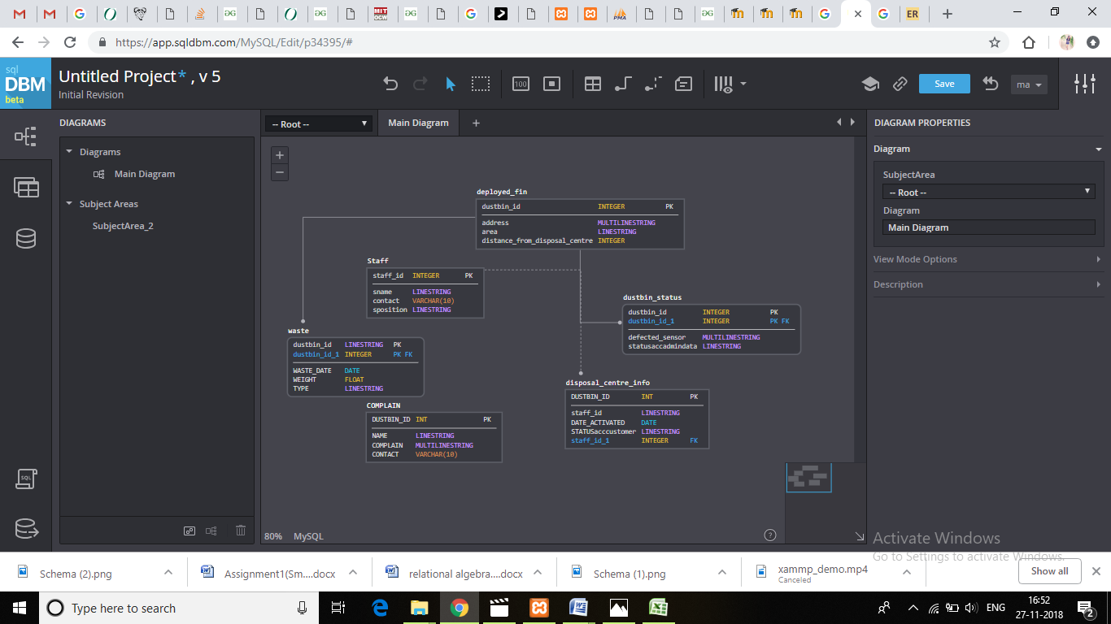

**E-R DIAGRAM**

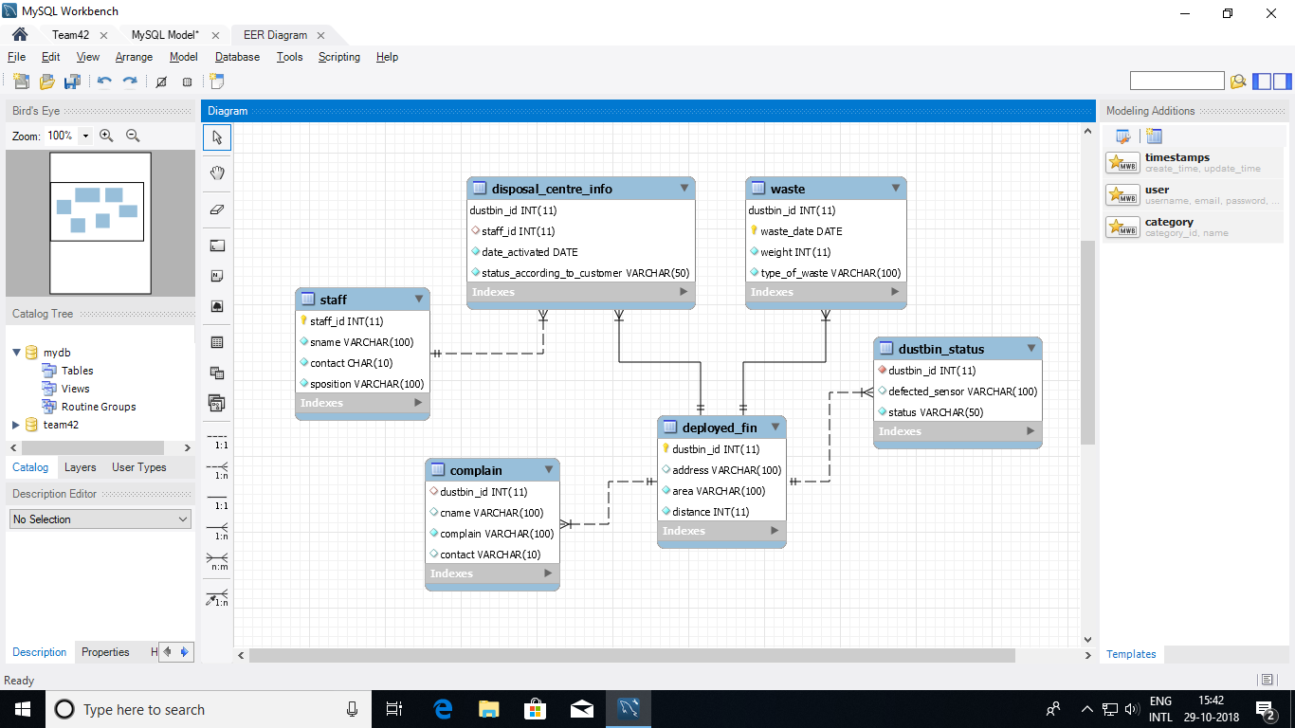

SQL QUERIES

1. Obtain the information of the dustbin where type of waste is Biodegradable and weight is greater than 50.

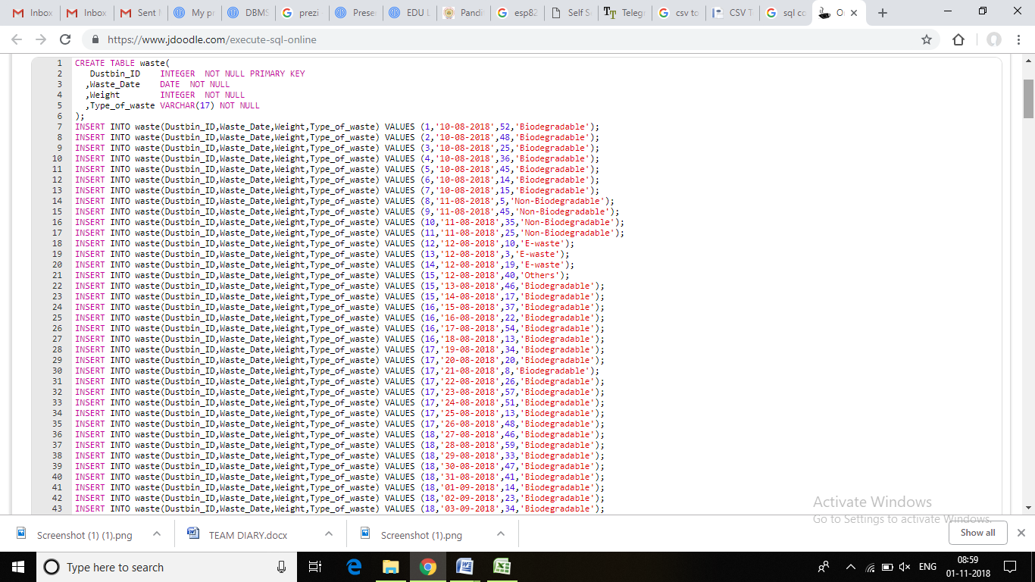

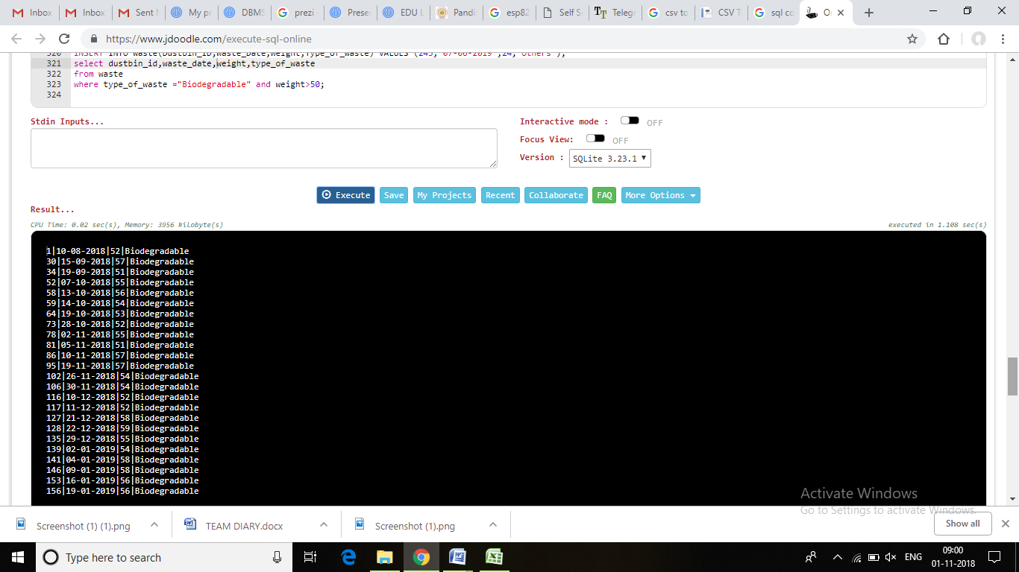

2)Obtain dustbin ids and defected sensor of the dustbins which are not working properly according to admin data

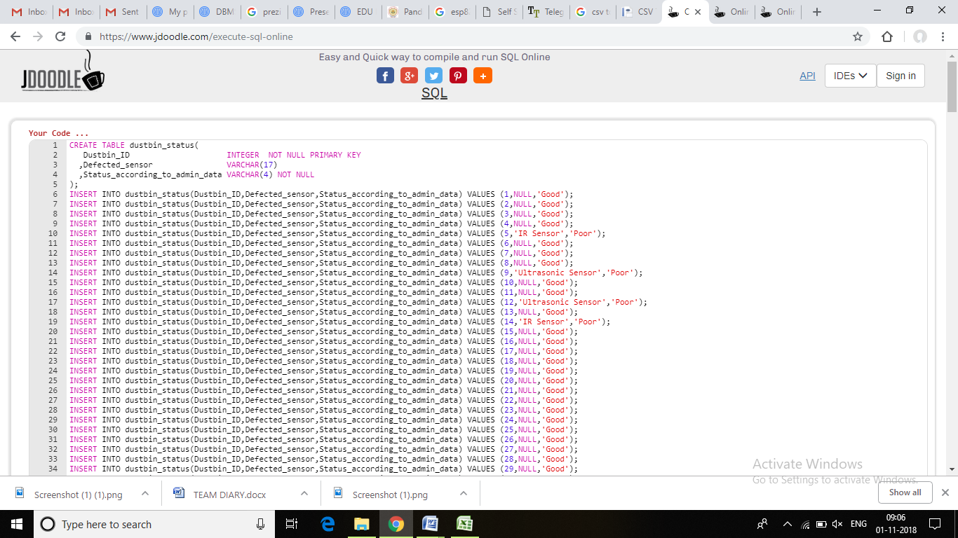

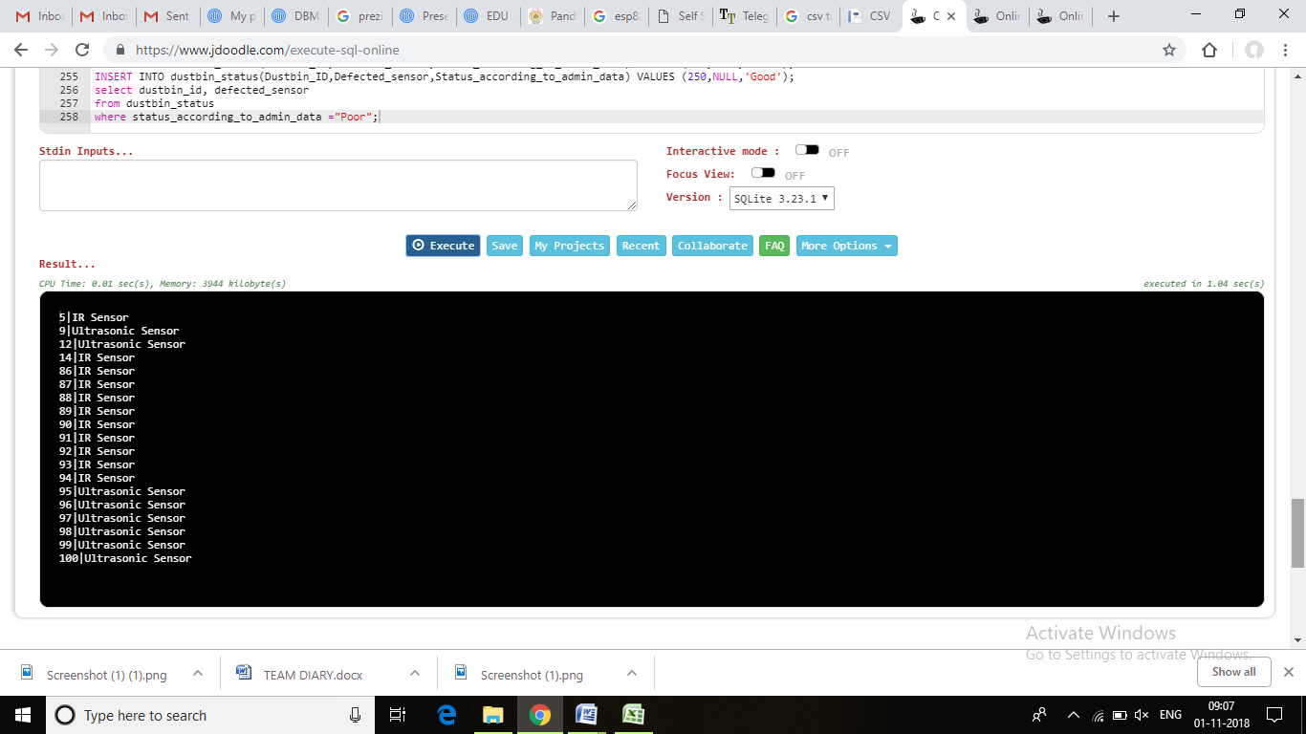

CURSORS

**declare**

**cursor** c **is** **select** * **from** waste;

**begin**

**for** r **in** c **loop**

**for** i **in** 1..r.quantity **loop**

**insert** **into** marbles **values** (

r.dustbin_id;

r.weight,

r.type_of_waste,

r.waste_date;

);

**end** **loop**;

**end** **loop**;

**end**;

**NORMALIZATION IN OUR PROJECT**

1. Table Name: Complain

Attributes:dustbin_id cname complain contact

Dependencies : dustbin_id      http://www.ict.griffith.edu.au/~jw/normalization/images/icon_arrow_right.png   cname    complain    contact

Minimal Cover:dustbin_id      http://www.ict.griffith.edu.au/~jw/normalization/images/icon_arrow_right.png   cname

dustbin_id      http://www.ict.griffith.edu.au/~jw/normalization/images/icon_arrow_right.png   complain

dustbin_id      http://www.ict.griffith.edu.au/~jw/normalization/images/icon_arrow_right.png   contact

Candidate Keys:dustbin_id

Check Normal Form:

1NF: YES

2NF: YES

3NF: YES

BCNF: YES

Normalize to 2NF:dustbin_id      http://www.ict.griffith.edu.au/~jw/normalization/images/icon_arrow_right.png   cname    complain    contact

Normalize to 3NF:dustbin_id      http://www.ict.griffith.edu.au/~jw/normalization/images/icon_arrow_right.png   cname    complain    contact

Normalize to BCNF:dustbin_id      http://www.ict.griffith.edu.au/~jw/normalization/images/icon_arrow_right.png   cname    complain    contact

2. Table Name: Staff

Attributes:staff_id,sname,contact,sposition

Dependencies: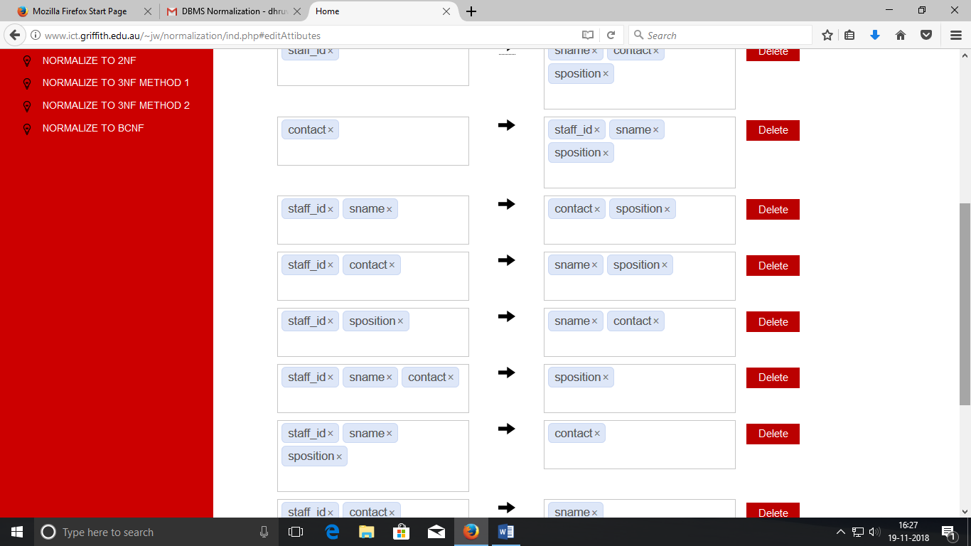

Minimal Cover:contact      http://www.ict.griffith.edu.au/~jw/normalization/images/icon_arrow_right.png  staff_id

contact      http://www.ict.griffith.edu.au/~jw/normalization/images/icon_arrow_right.png  sposition

staff_id      http://www.ict.griffith.edu.au/~jw/normalization/images/icon_arrow_right.png  contact

contact      http://www.ict.griffith.edu.au/~jw/normalization/images/icon_arrow_right.png  sname

Candidate Keys: staff_id   
 contact

Check Normal Form:

1NF: YES

2NF: YES

3NF: YES

BCNF: YES

Normalize to 2NF:contact      http://www.ict.griffith.edu.au/~jw/normalization/images/icon_arrow_right.png  staff_id    sposition    sname

staff_id      http://www.ict.griffith.edu.au/~jw/normalization/images/icon_arrow_right.png  contact

Normalize to 3NF:contact      http://www.ict.griffith.edu.au/~jw/normalization/images/icon_arrow_right.png  staff_id    sposition    sname

staff_id      http://www.ict.griffith.edu.au/~jw/normalization/images/icon_arrow_right.png  contact

Normalize to BCNF:contact      http://www.ict.griffith.edu.au/~jw/normalization/images/icon_arrow_right.png  staff_id    sposition    sname

staff_id      http://www.ict.griffith.edu.au/~jw/normalization/images/icon_arrow_right.png  contact

3. Table Name: deployed_fin

Attributes: dustbin_id,address, area, distance

Dependencies:dustbin_id      http://www.ict.griffith.edu.au/~jw/normalization/images/icon_arrow_right.png  address    distance

address      http://www.ict.griffith.edu.au/~jw/normalization/images/icon_arrow_right.png  area    dustbin_id

Minimal Cover:dustbin_id      http://www.ict.griffith.edu.au/~jw/normalization/images/icon_arrow_right.png  address

dustbin_id      http://www.ict.griffith.edu.au/~jw/normalization/images/icon_arrow_right.png  distance

address      http://www.ict.griffith.edu.au/~jw/normalization/images/icon_arrow_right.png  area

address      http://www.ict.griffith.edu.au/~jw/normalization/images/icon_arrow_right.png  dustbin_id

Candidate Keys:• dustbin_id

• address

Check Normal Form:

1NF: YES

2NF: YES

3NF: YES

BCNF: YES

Normalize to 2NF:dustbin_id      http://www.ict.griffith.edu.au/~jw/normalization/images/icon_arrow_right.png  address    distance

address      http://www.ict.griffith.edu.au/~jw/normalization/images/icon_arrow_right.png  area    dustbin_id

Normalize to 3NF:dustbin_id      http://www.ict.griffith.edu.au/~jw/normalization/images/icon_arrow_right.png  address    distance

address      http://www.ict.griffith.edu.au/~jw/normalization/images/icon_arrow_right.png  area    dustbin_id

Normalize to BCNF:dustbin_id      http://www.ict.griffith.edu.au/~jw/normalization/images/icon_arrow_right.png  address    distance

address      http://www.ict.griffith.edu.au/~jw/normalization/images/icon_arrow_right.png  area    dustbin_id

4. Table Name: disposal_centre_info

Attributes: dustbin_id, staff_id, date_activated, status_according_to_customer

Dependencies:

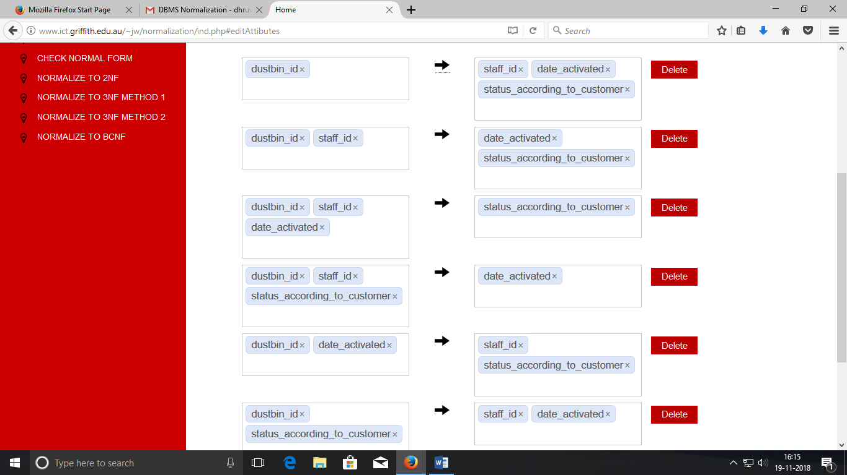

Minimal Cover:dustbin_id      http://www.ict.griffith.edu.au/~jw/normalization/images/icon_arrow_right.png  status_according_to_customer

dustbin_id      http://www.ict.griffith.edu.au/~jw/normalization/images/icon_arrow_right.png  staff_id

dustbin_id      http://www.ict.griffith.edu.au/~jw/normalization/images/icon_arrow_right.png  date_activated

Candidate Keys:dustbin_id

Check Normal Form:

1NF: YES

2NF: YES

3NF: YES

BCNF: YES

Normalize to 2NF:dustbin_id      http://www.ict.griffith.edu.au/~jw/normalization/images/icon_arrow_right.png  status_according_to_customer    staff_id    date_activated

Normalize to 3NF:dustbin_id      http://www.ict.griffith.edu.au/~jw/normalization/images/icon_arrow_right.png  status_according_to_customer    staff_id    date_activated

Normalize to BCNF:dustbin_id      http://www.ict.griffith.edu.au/~jw/normalization/images/icon_arrow_right.png  status_according_to_customer    staff_id    date_activated

5. Table Name: waste

Attributes: dustbin_id, waste_date, type_of_waste, weight

Dependencies:dustbin_id    waste_date      http://www.ict.griffith.edu.au/~jw/normalization/images/icon_arrow_right.png  type_of_waste    weight

Minimal Cover:dustbin_id    waste_date      http://www.ict.griffith.edu.au/~jw/normalization/images/icon_arrow_right.png  type_of_waste

dustbin_id    waste_date      http://www.ict.griffith.edu.au/~jw/normalization/images/icon_arrow_right.png  weight

Candidate Keys:dustbin_id waste_date

Check Normal Form:

1NF: YES

2NF: YES

3NF: YES

BCNF: YES

Normalize to 2NF:dustbin_id    waste_date      http://www.ict.griffith.edu.au/~jw/normalization/images/icon_arrow_right.png  type_of_waste    weight

Normalize to 3NF:dustbin_id    waste_date      http://www.ict.griffith.edu.au/~jw/normalization/images/icon_arrow_right.png  type_of_waste    weight

Normalize to BCNF:dustbin_id    waste_date      http://www.ict.griffith.edu.au/~jw/normalization/images/icon_arrow_right.png  type_of_waste    weight

6. Table Name: dustbin_status

Attributes: dustbin_id, defected_sensor, status

Dependencies:dustbin_id      http://www.ict.griffith.edu.au/~jw/normalization/images/icon_arrow_right.png  defected_sensor    status

Minimal Cover:dustbin_id      http://www.ict.griffith.edu.au/~jw/normalization/images/icon_arrow_right.png  defected_sensor

dustbin_id      http://www.ict.griffith.edu.au/~jw/normalization/images/icon_arrow_right.png  status

Candidate Keys: dustbin_idS

Check Normal Form:

1NF: YES

2NF: YES

3NF: YES

BCNF: YES

Normalize to 2NF:dustbin_id      http://www.ict.griffith.edu.au/~jw/normalization/images/icon_arrow_right.png  defected_sensor    status

Normalize to 3NF:dustbin_id      http://www.ict.griffith.edu.au/~jw/normalization/images/icon_arrow_right.png  defected_sensor    status

Normalize to BCNF:dustbin_id      http://www.ict.griffith.edu.au/~jw/normalization/images/icon_arrow_right.png  defected_sensor    status